 | Monday | Tuesday | Wednesday | Thursday | Friday
WEEK 1  Jungle | 27  First Day of Camp & Introductions  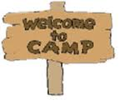 | 28  Creek | 29 | 30  Creek | 1  Bring Your Stuffed Animal to Camp!
WEEK 2  Stars/Stripes | 4  NO CAMP! | 5  Creek | 6  Splashworld ($30) | 7  Creek  CIT – Rock Climbing | 8
WEEK 3  Superheroes | 11  CIT vs. Tall Pines @ HOME 10:30-12pm | 12  Creek | 13  Sky Zone ($27) | 14  Creek  CIT – Ronald McDonald House | 15  Dress like a Superhero Day!
WEEK 4  Around the World | 18  CIT vs. Tall Pines @ AWAY 10:15-12pm | 19  Creek | 20  Bowling ($15) | 21  Creek | 22
WEEK 5  Olympics | 25  Opening Ceremony | 26  Creek | 27  Union Soccer Fun Day ($26) | 28  Creek  CIT- Food Bank | 29  Closing Ceremonies  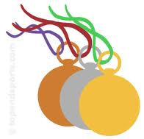
WEEK 6  Hollywood | 1 | 2  Creek | 3  Ice Skating ($18) | 4  Creek  CIT – Canoe Trip | Talent Show! 5
WEEK 7  Moovin’/Groovin | Rock & Roll Day! 8 | Country Day! 9  Creek | Pop Music Day! 10 | Oldies Day! 11  Creek | Campout @ 6pm 12  ($25)  Camp ends @ 2pm
WEEK 8  Bunk Wars | Crazy Hair Day! 15 | Twin Day! 16  Creek  CIT – Shore Trip | 17  Throwback Shirt Day! | Crazy Sock Day! 18  Creek | Carnival 19  